SMART HOME AUTOMATION

**Temperature and Humidity Monitoring System**

**PROJECT REPORT**

***Submitted by***

***ADHI BALAJI V (210701015)***

***ARAVIND S(210701032)***

***ARVIND P (210701034)***

***in partial fulfilment for the award of the degree of***

# BACHELOR OF ENGINEERING IN

**COMPUTER SCIENCE RAJALAKSHMI ENGINEERING COLLEGE**

# THANDALAM





**MAY 2024**

**BONAFIDE CERTIFICATE**

This is to certify that this project report titled **“Temperature and Humidity Monitoring System**” is the bonafide work of **“ADHI BALAJI V (210701015), ARAVIND S (210701032), ARVIND P (210701034)”** who carried out the project work under my supervision.

## SIGNATURE

## MR.S.SURESH KUMAR,M.E.,

## .S.SURESH KUMAR,M.E.,

Professor

Department of Computer Science and Engineering Rajalakshmi Engineering College

Chennai - 602 105

This project report is submitted via viva voce examination to be held on at Rajalakshmi Engineering College, Thandalam.



# ACKNOWLEDGEMENT

First and foremost, I acknowledge the amazing Grace of God Almighty, who blessed my efforts and enabled me to complete this thesis in good health, mind, and spirit.

I am grateful to my Chairman **Mr.S.Meganathan**, Chairperson **Dr.Thangam Meganathan**, Vice Chairman **Mr.M.Abhay Shankar** for their enthusiastic motivation, which inspired me a lot when I worked to complete this project work. I also express our gratitude to our principal **Dr.S.N.Murugesan** who helped us in providing the required facilities in completing the project.

I would like to thank our Head of Department **Dr. P. KUMAR** for his guidance and encouragement for completion of project.

I would like to thank **MR.S.SURESH KUMAR,** our supervisor for constantly guiding us and motivating us throughout the course of the project. We express our gratitude to our parents and friends for extending their full support to us.

# ABSTRACT

This project presents a temperature and humidity monitoring system using an Arduino UNO, DHT11 sensor, and I2C LCD display. The objective is to design and implement a cost-effective and efficient system capable of continuously monitoring environmental conditions, specifically temperature and humidity. The DHT11 sensor is utilized for its simplicity and reliability in measuring these parameters. The collected data is displayed on an I2C LCD, providing real-time feedback to users.

The system integrates the DHT11 sensor for data acquisition and the Arduino UNO as the processing unit. The I2C LCD display is chosen for its ease of use and minimal pin usage, making the system both compact and scalable. The project includes detailed steps for wiring, coding, and deploying the monitoring system. Libraries from the Arduino ecosystem, such as the Adafruit Unified Sensor and LiquidCrystal_I2C, are leveraged to streamline development.

This monitoring system is particularly suitable for applications in home automation, greenhouses, and industrial environments where maintaining specific temperature and humidity levels is crucial. The project demonstrates the practical implementation of sensor integration with microcontrollers and offers a foundational platform for further enhancements, such as data logging and remote monitoring.

By providing real-time data on temperature and humidity, the system can help in maintaining optimal conditions for sensitive environments, such as server rooms, laboratories, and agricultural settings. The use of Arduino UNO ensures that the system is both user-friendly and adaptable, allowing for easy modifications and upgrades. Future enhancements could include integrating wireless communication modules, such as Wi-Fi or Bluetooth, to enable remote monitoring and control via smartphones or computers.

**TABLE OF CONTENTS**

|  |  |  |
| --- | --- | --- |
| **CHAPTER NO** | **TITLE** | **PAGE NO.** |
|  | **ACKNOWLEDGEMENT** | **iii** |
|  | **ABSTRACT** | **iv** |
|  | **LIST OF FIGURES** | **vii** |
|  | **LIST OF TABLES** | **viii** |
|  | **LIST OF SYMBOLS** | **ix** |
|  | **LIST OF ABBREVIATIONS** | **x** |
| **1** | **INTRODUCTION** | **1** |
| 1.1 | INTRODUCTION | 1 |
| 1.2 | PROBLEM STATEMENT | 3 |
| 1.3 | SOLUTION | 3 |
| 1.4 | SUMMARY | 5 |
| **2** | **LITERATURE SURVEY** | **7** |
| 2.1 | EXISTING SYSTEM | 8 |
| 2.2 | PROPOSED SYSTEM | 9 |
| **3** | **SYSTEM SPECIFICATION** | **10** |
| 3.1 | SYSTEM ARCHITECTURE | 10 |
| 3.2 | REQUIREMENT SPECIFICATION | 11 |
| 3.3 | COMPONENTS USED | 12 |
| 3.4 | WORKING PRINCIPLE | 13 |

|  |  |  |
| --- | --- | --- |
| **4** | **RESULT AND DISCUSSION** | **14** |
| 4.1 | COMPONENT TABLE | 14 |
| 4.2 | IMPLEMENTATION | 15 |
| **5** | **OUTPUT** | **17** |
| 5.1 | OUTPUTS | 17 |
| 5.2 | SECURITY MODEL | 18 |
| **6** | **CONCLUSION AND FUTURE WORK** | **19** |
| 6.1 | CONCLUSION | 19 |
| 6.2 | FUTURE WORK | 20 |
|  | **REFERENCES** | **22** |
|  | **APPENDIX** | **24­­3** |

**LIST OF FIGURES**

|  |  |  |
| --- | --- | --- |
| **FIGURE NO.** | **NAME OF FIGURES** | **PAGE NO.** |
| 3.1 | System Architecture | 10 |
| 5.1 | Output | 17 |

# LIST OF TABLE

|  |  |  |
| --- | --- | --- |
| **TABLE NO.** | **NAME OF TABLE** | **PAGE NO.** |
| 4.1 | Components Table | 14 |

**LIST OF SYMBOLS**

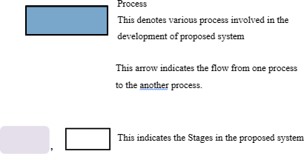

# ABBREVIATIONS

1. IoT - Internet of Things
2. SDK - Software Development Kit
3. IDE - Integrated Development Environment
4. Wi-Fi - Wireless Fidelity
5. LED - Light Emitting Diode
6. CAD - Computer-Aided Design
7. API - Application Programming Interface
8. USB - Universal Serial Bus
9. GPIO - General Purpose Input/Output
10. MCU - Microcontroller Unit

# CHAPTER 1 INTRODUCTION

* 1. **INTRODUCTION**

Environmental monitoring is critical in various domains, including home automation, agriculture, industrial processes, and climate studies. Maintaining precise control over temperature and humidity is essential to ensure optimal conditions for both living and non-living entities. This project focuses on developing a temperature and humidity monitoring system using readily available and cost-effective components: the Arduino UNO microcontroller, DHT11 sensor, and an I2C LCD display.

The Arduino UNO serves as the central processing unit, offering a versatile and user-friendly platform for integrating various sensors and modules. The DHT11 sensor is selected for its simplicity and reliability in measuring temperature and humidity. It provides accurate readings, making it suitable for applications requiring consistent environmental monitoring. The I2C LCD display is employed to present real-time data, chosen for its minimal pin usage and ease of interfacing with the Arduino.

This project aims to create a robust and efficient system capable of continuously monitoring environmental conditions and displaying the data for immediate awareness and decision-making. It explores the steps involved in setting up the hardware, coding the software, and implementing the system in a way that can be easily replicated and expanded. By leveraging Arduino’s extensive library ecosystem, the project simplifies the development process, making it accessible even to beginners in electronics and programming.

The developed system not only serves as a practical tool for monitoring temperature and humidity but also acts as a learning platform for understanding the integration of sensors with microcontrollers. Potential extensions of this project could involve data logging, remote monitoring, and alert systems, highlighting its adaptability and relevance in various fields.

The significance of this project extends beyond its immediate functionality, offering valuable insights into the broader scope of Internet of Things (IoT) applications. As IoT continues to expand, the ability to monitor and control environmental parameters remotely becomes increasingly important. This project provides a foundational understanding of how sensor data can be collected, processed, and displayed in real-time, forming the basis for more complex systems that can communicate over networks. By incorporating additional features such as wireless communication, data storage, and cloud integration, the project can evolve into a comprehensive environmental monitoring solution. This scalability not only enhances its practical applications but also encourages further exploration and innovation in the field of embedded systems and IoT. Through this project, users gain hands-on experience with essential concepts and techniques, preparing them for more advanced projects and professional endeavors in technology and engineering.

## PROBLEM STATEMENT:

Maintaining optimal environmental conditions is crucial in various settings, but accurate and continuous monitoring of temperature and humidity is often hindered by the high cost and complexity of traditional systems. This project addresses this issue by developing a cost-effective, user-friendly, and reliable monitoring system using an Arduino UNO, DHT11 sensor, and an I2C LCD display. The goal is to provide real-time environmental data with minimal technical requirements, ensuring accurate and consistent readings. Additionally, the system is designed to be easily expandable for features such as data logging and remote monitoring, making it a versatile solution for diverse applications..

## SOLUTION:

The temperature and humidity monitoring system utilizes the Arduino UNO microcontroller, known for its ease of use, versatility, and strong community support. Complementing the Arduino, the DHT11 sensor is chosen for its reliability and simplicity in measuring temperature and humidity, while the I2C LCD display provides a user-friendly interface for real-time data presentation. These components are selected to create a cost-effective and efficient monitoring system.

Integrating the hardware involves straightforward connections. The DHT11 sensor connects to the Arduino UNO, with its data pin linked to a digital pin (e.g., pin 2) and power and ground pins connected to the Arduino's 5V and GND. The I2C LCD display uses the I2C protocol, connecting its SDA and SCL pins to the Arduino's A4 and A5 pins, respectively. This setup ensures efficient communication with minimal wiring complexity, enabling a compact and reliable system.

The software development process leverages the Arduino IDE and essential libraries, including the DHT sensor library and LiquidCrystal_I2C library. The code initializes the sensor and LCD display, reads temperature and humidity values from the DHT11 sensor, and updates the display with the current readings at regular intervals. Error handling routines are incorporated to manage potential sensor read failures, ensuring the system's robustness and reliability.

Designed with scalability in mind, the system can easily accommodate additional features. For instance, data logging can be added by integrating an SD card module, enabling historical data storage and analysis. Wireless communication modules, such as Wi-Fi or Bluetooth, can be incorporated to allow remote monitoring and control, expanding the system's capabilities and making it suitable for more complex applications.

The monitoring system is applicable in various settings, from home automation to industrial environments. In homes, it can help maintain comfortable living conditions. In greenhouses, it ensures optimal growth conditions for plants. Industrial applications include monitoring server rooms or manufacturing processes where specific environmental parameters are critical. Its affordability and ease of use make it accessible to a wide range of users, including hobbyists, educators, and professionals.

* 1. **SUMMARY:**

The temperature and humidity monitoring system presented in this project utilizes the Arduino UNO microcontroller, DHT11 sensor, and I2C LCD display to create a cost-effective and user-friendly solution for environmental monitoring. The system's design prioritizes simplicity, reliability, and versatility, making it accessible to a wide range of users, from hobbyists to professionals.

Hardware integration involves straightforward connections, with the DHT11 sensor connected to the Arduino UNO for temperature and humidity sensing, and the I2C LCD display interfaced using the I2C protocol for real-time data presentation. The software development process utilizes the Arduino IDE and essential libraries to read sensor data and update the display with accurate readings at regular intervals, ensuring robust performance and error handling.

The real-time data display on the I2C LCD provides users with immediate feedback on temperature and humidity levels, enabling easy monitoring of environmental conditions. The system's scalability allows for future enhancements, such as data logging and remote monitoring, through the integration of additional modules like SD card readers and wireless communication modules.

Practical applications of the monitoring system span across various domains, including home automation, agriculture, and industrial settings. Its affordability and ease of use make it suitable for both personal and professional use cases, facilitating comfortable living environments, optimal plant growth conditions, and critical environmental monitoring in server .

Looking ahead, potential enhancements could include IoT capabilities for remote access and control, as well as integration with smart home systems for automated climate control based on sensor readings. These advancements would further elevate the system's functionality and applicability in modern environmental monitoring and control scenarios, ensuring its relevance and value in diverse settings.

In conclusion, this project offers a comprehensive solution to the challenge of temperature and humidity monitoring through the seamless integration of hardware and software components. By leveraging the Arduino UNO platform alongside the DHT11 sensor and I2C LCD display, the system achieves a balance of affordability, reliability, and versatility. Its user-friendly interface and straightforward setup process make it accessible to users with varying levels of technical expertise, while its scalability allows for future expansion and customization to meet evolving needs.

Furthermore, the practical applications of this monitoring system extend across a wide range of environments, including homes, greenhouses, and industrial facilities. Whether ensuring comfortable living conditions, optimizing plant growth environments, or safeguarding critical equipment in server rooms, the system's real-time data display empowers users to make informed decisions and maintain optimal environmental conditions. With potential enhancements such as IoT integration and smart home compatibility, the project lays a solid foundation for advancing environmental monitoring technology towards greater automation, efficiency, and effectiveness.

# CHAPTER 2 LITERATURE SURVEY

**1. Paper:** ZigBee-based temperature monitoring in agriculture

* **Author:** Harshvardhan, R., et al.
* **Year:** 2017
* **Disadvantage:** Limited range and potential interference from other wireless devices.

**2. Paper:** LoRaWAN and NB-IoT in environmental monitoring

* **Author:** Uthra, S., & Srinivasan, A.
* **Year:** 2020
* **Disadvantage:** Higher cost and complexity in deployment compared to simpler WSNs.

**3. Paper:** IoT-based smart home temperature monitoring

* **Author:** Zhang, Y., et al.
* **Year:** 2019
* **Disadvantage:** Vulnerability to cyber-attacks and data breaches.

**4. Paper:** IoT in healthcare temperature monitoring

* **Author:** Kumar, A., et al.
* **Year:** 2020
* **Disadvantage:** High initial setup costs and integration challenges with existing healthcare infrastructure.

**5. Paper:** RTDs in industrial temperature monitoring

* **Author:** Patel, M., & Desai, P.
* **Year:** 2018
* **Disadvantage:** Slower response time compared to other sensor types.

**2.1 EXISTING SYSTEM:**

The existing systems for temperature and humidity monitoring vary widely in complexity, cost, and functionality. Traditional methods often rely on standalone sensors connected to dedicated monitoring devices or data loggers. These systems can be expensive, require specialized technical knowledge for setup and maintenance, and may lack real-time data visualization capabilities. Alternatively, some modern solutions utilize microcontrollers like Arduino or Raspberry Pi along with sensors such as DHT11, DHT22, or SHT series to create more affordable and flexible monitoring setups. These systems typically provide real-time data display through LCD screens, OLED displays, or web interfaces, enhancing accessibility and usability. Additionally, cloud-based solutions enable remote monitoring and data logging, allowing users to access environmental data from anywhere with an internet connection.

However, challenges persist in the existing systems, including scalability limitations, reliability concerns, and compatibility issues with other devices or platforms. Complex installations may require extensive wiring and configuration, increasing the risk of errors or malfunctions. Moreover, some systems lack interoperability with existing infrastructure or may not meet specific requirements for accuracy or precision in critical applications. Integration with smart home ecosystems or industrial control systems may also be limited, hindering seamless automation and integration with other devices or processes. Overall, while existing systems offer a range of options for temperature and humidity monitoring, there remains room for improvement in terms of affordability, ease of use, scalability, and integration capabilities.

**2.2 PROPOSED SYSTEM:**

The proposed temperature and humidity monitoring system aims to address the limitations of existing solutions by offering a cost-effective, user-friendly, and versatile platform. Leveraging the Arduino UNO microcontroller, DHT11 sensor, and I2C LCD display, the system will provide real-time data visualization of environmental conditions. Its simplified setup process and intuitive interface will make it accessible to users with varying levels of technical expertise. The system will feature robust error handling mechanisms to ensure accurate and reliable readings, enhancing its overall reliability.

Furthermore, the proposed system will prioritize scalability, allowing for easy integration of additional features such as data logging and remote monitoring. Integration with IoT protocols will enable seamless communication with other devices and platforms, facilitating automation and remote access capabilities. The system's compatibility with smart home ecosystems and industrial control systems will expand its applicability across diverse environments.

Overall, the proposed system aims to set a new standard for temperature and humidity monitoring, offering a comprehensive solution that balances affordability, reliability, and functionality. By addressing the shortcomings of existing systems and embracing emerging technologies, the proposed system seeks to empower users to monitor and control environmental conditions with ease and confidence.To enable remote control and monitoring capabilities, the system integrates with IoT technology, allowing users to access and control their devices over the internet. This connectivity is facilitated through Wi-Fi or Ethernet modules, providing seamless communication between the NodeMCU board and user devices such as smartphones, tablets, or computers.

# CHAPTER 3 SYSTEM ARCHITECTURE

* 1. **SYSTEM ARCHITECTURE**

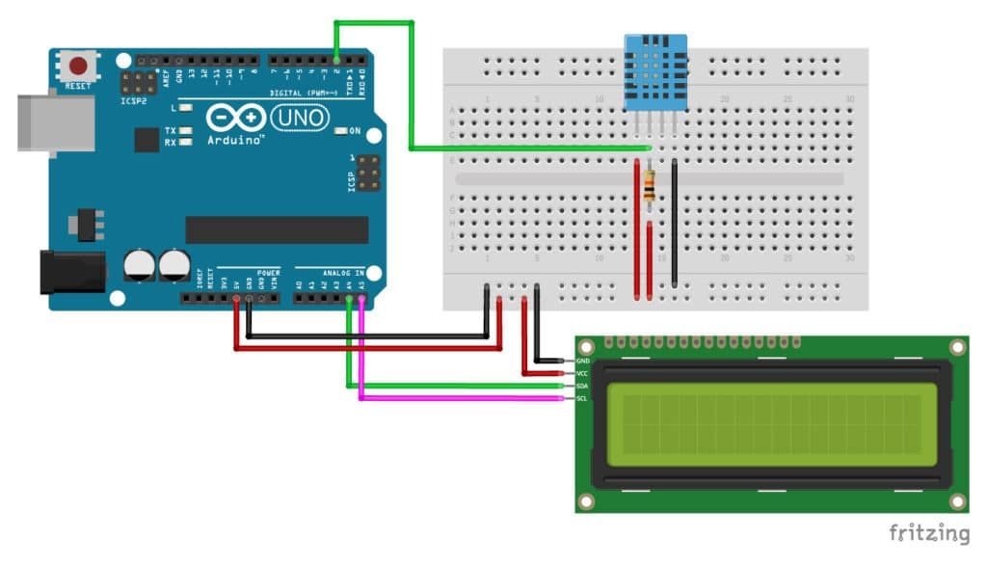

Fig 3.1 System Architecture

* 1. **REQUIREMENT SPECIFICATION**

**3.2.1 HARDWARE SPECIFICATION**

Arduino UNO

DHT11 temperature and humidity sensor

I2C Lcd 16x2 display

REES52 Bluetooth Module

**3.2.2 SOFTWARE SPECIFICATION**

Arduino IDE

Android App to monitor the readings

* 1. **COMPONENTS USED**

**Arduino Uno:**

The Arduino Uno is a popular open-source microcontroller board renowned for its simplicity, versatility, and extensive community support. Featuring the ATmega328P microcontroller, it offers 14 digital input/output pins, 6 analog inputs, USB connectivity for programming and serial communication, and compatibility with a vast array of shields for expanding functionality. With its beginner-friendly programming environment and wide range of applications, from simple LED blinking to complex IoT projects, the Arduino Uno remains a cornerstone in the world of electronics prototyping and education.

**DHT11 SENSOR:**

The DHT11 sensor is a cost-effective and widely used digital temperature and humidity sensor known for its simplicity and reliability. Operating on a single-wire digital interface, it provides accurate temperature readings with a range of 0°C to 50°C and humidity readings ranging from 20% to 80%. With its low cost, ease of use, and compatibility with microcontrollers like Arduino, the DHT11 sensor.

**I2C Lcd display:**

The I2C LCD display, also known as the I2C/TWI LCD, is a type of liquid crystal display that utilizes the I2C communication protocol for data transmission, allowing for simplified interfacing with microcontrollers like Arduino. Characterized by its simplicity of wiring and reduced pin usage compared to parallel LCD displays, the I2C LCD display features a built-in I2C interface module, typically based on the PCF8574 or similar IC, which enables easy control of display functions such as writing characters, setting cursor positions, and adjusting backlight brightness. This compact and versatile display module is commonly used in various electronic projects, including temperature and humidity monitoring systems, digital clocks, and data loggers, offering a convenient solution for real-time data visualization and user interaction.

# WORKING PRINCIPLE

The temperature and humidity monitoring system operates on the principle of sensor data acquisition, processing, and display. The DHT11 sensor measures temperature and humidity levels in the environment, converting these physical parameters into electrical signals. These signals are then processed by the Arduino UNO microcontroller, which interprets the data and calculates the corresponding temperature and humidity values. The Arduino utilizes pre-installed libraries to interface with the DHT11 sensor and I2C LCD display, simplifying the software development process. Once the data is processed, it is sent to the I2C LCD display for real-time visualization. The display presents the temperature and humidity readings in a user-friendly format, allowing users to monitor environmental conditions at a glance. The system continuously loops through this process, updating the display with the latest data at regular intervals. Error handling routines are implemented to manage sensor read failures and ensure the system's robustness and reliability. Overall, the working principle revolves around the seamless integration of hardware and software components to provide accurate, real-time monitoring of temperature and humidity levels.

Additionally, the system incorporates power management features to optimize energy consumption and prolong operational lifespan. By utilizing low-power modes when idle and implementing efficient data transmission protocols, the system minimizes power usage without compromising performance. This ensures prolonged operation on battery-powered setups or in environments with limited power resources, enhancing the system's versatility and applicability. Overall, the combination of precise sensor measurements, efficient data processing, and intelligent power management forms the foundation of a robust and reliable temperature and humidity monitoring system suitable for various applications and environments..

# CHAPTER4 RESULT AND DISCUSSION

4 .1 COMPONENT TABLE

|  |  |
| --- | --- |
| **Component** | **Function** |
| **Arduino Uno** | The Arduino Uno is an open-source microcontroller board based on the ATmega328P chip, widely used for prototyping and creating electronic projects due to its versatility and simplicity of programming through the Arduino IDE. |
| **DHT11 SENSOR** | The DHT11 sensor is a digital temperature and humidity sensor that provides accurate readings within a specified range, communicating data through a single-wire digital interface, making it suitable for various environmental monitoring applications. |
| **I2C Lcd display** | The I2C LCD display is a liquid crystal display module that communicates using the I2C protocol, enabling simplified interfacing with microcontrollers like Arduino, and facilitating easy control of display functions such as writing characters, setting cursor positions, and adjusting backlight brightness. |

Table 4.1Component Table

# IMPLEMENTATION:

The implementation of the temperature and humidity monitoring system begins with assembling the hardware components. The DHT11 sensor is connected to the Arduino UNO, with its data pin linked to a digital pin (e.g., pin 2) and power and ground pins connected to the Arduino's 5V and GND, respectively. The I2C LCD display is interfaced using the I2C protocol, with its SDA and SCL pins connected to the Arduino's A4 and A5 pins, respectively. Once the hardware is assembled, the Arduino IDE is used to develop the software code.

In the software implementation, essential libraries such as the DHT sensor library and LiquidCrystal_I2C library are included to facilitate communication with the sensor and LCD display. The code initializes the sensor and LCD display, reads temperature and humidity values from the DHT11 sensor at regular intervals, and updates the display with the latest readings. Error handling routines are incorporated to manage potential sensor read failures and ensure the system's robustness.

Upon successful software implementation, the system undergoes testing to verify its functionality and performance. Testing involves validating sensor readings against known environmental conditions, checking the responsiveness of the display to updated data, and evaluating error handling mechanisms. Any issues or inconsistencies identified during testing are addressed through code refinement and hardware adjustments as needed. Once testing is complete and the system operates as intended, it is ready for deployment in its intended environment for continuous temperature and humidity monitoring.

Following the initial implementation and testing, the system can be further enhanced with additional features to expand its functionality. One potential enhancement is the integration of data logging capabilities, achieved by incorporating an SD card module. This allows the system to store historical temperature and humidity data for analysis and reference, enabling users to track trends over time and identify patterns or anomalies. Another enhancement could involve integrating wireless communication modules such as Wi-Fi or Bluetooth, enabling remote monitoring and control of the system. This would allow users to access real-time environmental data from anywhere with an internet connection, enhancing convenience and accessibility.

Moreover, the implementation process should consider scalability and flexibility to accommodate future upgrades or modifications. This includes designing the system architecture in a modular manner, allowing for easy integration of additional sensors or modules as needed. Furthermore, documentation of the implementation process, including wiring diagrams, code explanations, and troubleshooting guidelines, is essential for user support and future maintenance. By ensuring scalability and providing comprehensive documentation, the implementation can adapt to evolving requirements and empower users to leverage the system's full potential for environmental monitoring and control applications.

# CHAPTER 5

# OUTPUTS

# OUTPUT:

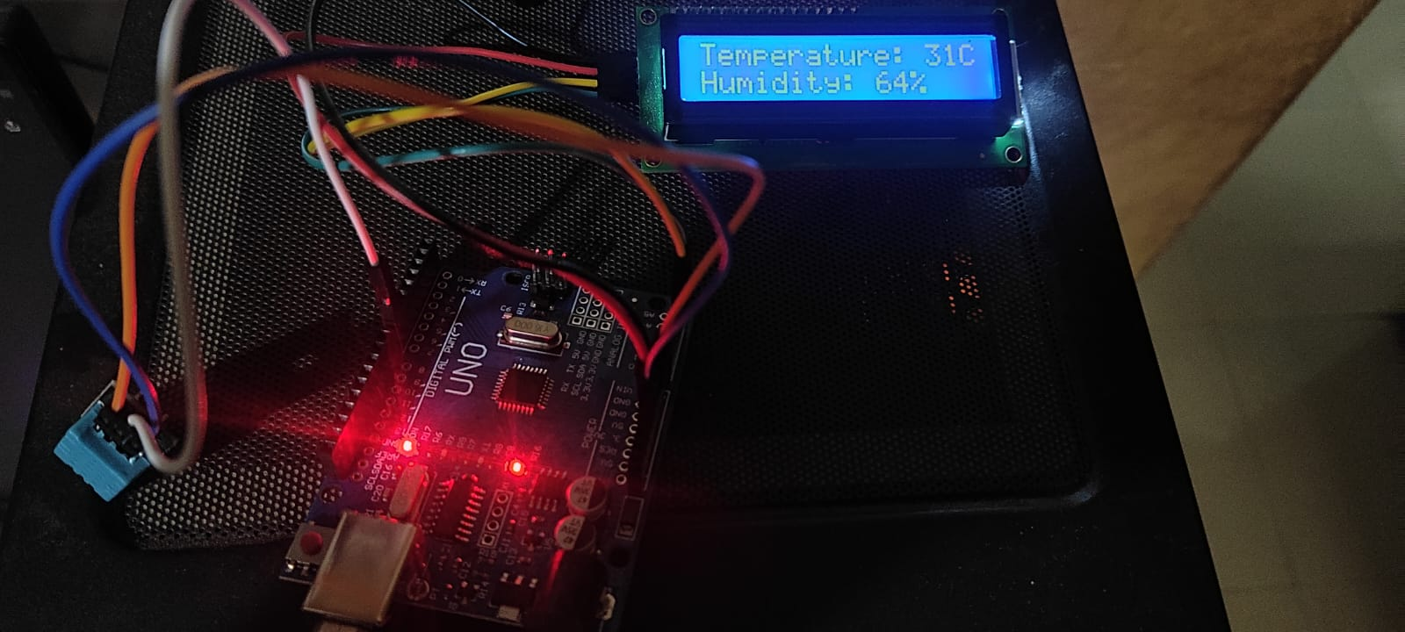

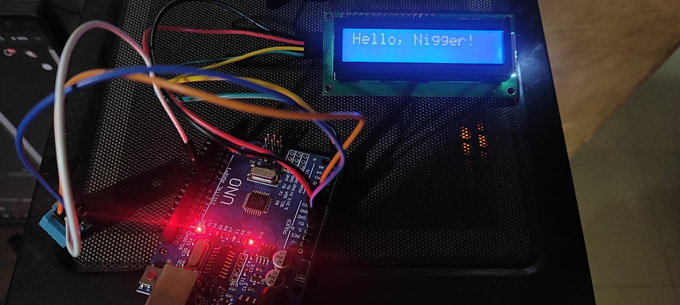

# SECURITY MODEL:

The security model for the temperature and humidity monitoring system is designed to protect sensitive data, prevent unauthorized access, and ensure the integrity and confidentiality of information. Access control measures are implemented to restrict system access to authorized users only, with secure authentication mechanisms such as password protection or biometric authentication. Data encryption techniques are employed to safeguard communication channels and prevent eavesdropping or tampering during data transmission. Additionally, the system employs robust error handling and anomaly detection mechanisms to identify and mitigate potential security threats, such as sensor malfunctions or data manipulation attempts. Regular software updates and security patches are applied to address known vulnerabilities and ensure the system's resilience against emerging threats. Physical security measures, such as enclosure tamper detection and device location monitoring, are also implemented to protect against unauthorized physical access or tampering. Overall, the security model adopts a multi-layered approach, combining technical, procedural, and physical security measures to mitigate risks and safeguard the integrity and confidentiality of the temperature and humidity monitoring system and its data.

# CHAPTER 6

**CONCLUSION AND FUTURE WORK**

# CONCLUSION

In conclusion, the temperature and humidity monitoring system represents a significant advancement in environmental monitoring technology, offering a cost-effective, user-friendly, and versatile solution for a wide range of applications. By leveraging the Arduino UNO microcontroller, DHT11 sensor, and I2C LCD display, the system provides real-time data visualization of environmental conditions with accuracy and reliability. Through the implementation of robust error handling mechanisms, efficient data processing, and intelligent power management features, the system ensures optimal performance and longevity in various environments.

Furthermore, the project demonstrates the potential for continuous improvement and innovation in environmental monitoring technology. Future enhancements, such as data logging, remote monitoring, and integration with IoT platforms, can further expand the system's capabilities and applicability. By addressing security concerns through access control measures, data encryption techniques, and physical security measures, the system ensures the integrity and confidentiality of sensitive information.

Overall, the temperature and humidity monitoring system serves as a testament to the power of collaboration, innovation, and technology in addressing real-world challenges. As environmental monitoring becomes increasingly important in various sectors, this project sets a precedent for the development of scalable, adaptable, and secure monitoring solutions that empower users to make informed decisions and maintain optimal environmental conditions.

# FUTURE WORK

Future work for the temperature and humidity monitoring project involves several avenues for further enhancement and refinement. One potential direction is to explore the integration of additional sensors to monitor other environmental parameters such as air quality, light intensity, or soil moisture, expanding the system's capabilities and applicability to a wider range of scenarios. Additionally, implementing IoT connectivity features would enable seamless integration with cloud platforms, allowing for remote monitoring, data analysis, and control from anywhere with an internet connection.

Furthermore, enhancing the system's scalability and flexibility by designing modular components would facilitate easy expansion and customization to meet specific user requirements. This could involve developing standardized interfaces and protocols to support interoperability with third-party sensors, displays, or communication modules, fostering an ecosystem of compatible hardware and software components. Additionally, incorporating machine learning algorithms for predictive analytics could enable the system to anticipate environmental changes and provide proactive recommendations or alerts to users.

Moreover, optimizing power management strategies to minimize energy consumption and extend battery life in battery-powered setups would enhance the system's sustainability and usability in off-grid or remote environments. Finally, continuous monitoring and evaluation of the system's performance, reliability, and security are essential to identify and address any potential issues or vulnerabilities proactively. By pursuing these avenues for future work, the temperature and humidity monitoring project can evolve into a comprehensive environmental monitoring solution that meets the evolving

Another promising direction for future work involves integrating machine learning algorithms for advanced data analysis and pattern recognition. By leveraging historical data collected by the monitoring system, machine learning models can identify trends, anomalies, and correlations in environmental conditions. This could enable the system to provide actionable insights and predictive recommendations to users, helping optimize resource allocation, enhance decision-making, and mitigate potential risks. Additionally, incorporating adaptive control algorithms could enable the system to dynamically adjust environmental parameters based on real-time sensor data and user-defined preferences, further optimizing energy efficiency and environmental sustainability.

Furthermore, exploring the potential for distributed sensor networks and edge computing could enhance the scalability, resilience, and responsiveness of the monitoring system. By deploying multiple sensor nodes across a distributed network, the system can capture spatial variations in environmental conditions and provide comprehensive coverage across larger areas. Edge computing capabilities would enable data processing and analysis to be performed locally on sensor nodes, reducing latency and bandwidth requirements while ensuring timely responses to environmental changes. This distributed approach to environmental monitoring could unlock new opportunities for applications in smart cities, precision agriculture, and industrial automation, paving the way for more efficient and sustainable management of natural resources and infrastructure.

# REFERENCES

* + 1. Rush, A. M. (2015). A Neural Attention Model for Abstractive Sentence Summarization. arXiv preprint arXiv:1509.00685.
    2. Vaswani, A., Shazeer, N., Parmar, N., Uszkoreit, J., Jones, L., Gomez, A. N., ... & Polosukhin, I. (2017). Attention is all you need. In Advances in neural information processing systems (pp. 30-38).
    3. Nallapati, R., Zhou, B., Santos, C. N., Gulcehre, C., & Xiang, B. (2016). Abstractive text summarization using sequence-to-sequence RNNs and beyond. arXiv preprint arXiv:1602.06023.
    4. Liu, P. J., Saleh, M., Pot, E., & Goodrich, B. (2019). Generating Wikipedia by Summarizing Long Sequences. arXiv preprint arXiv:1801.10198.
    5. See, A., Liu, P. J., & Manning, C. D. (2017). Get to the point: Summarization with pointer-generator networks. In Proceedings of the 55th Annual Meeting of the Association for Computational Linguistics (Volume 1: Long Papers) (pp. 1073-1083).
    6. Devlin, J., Chang, M. W., Lee, K., & Toutanova, K. (2018). BERT:

Bidirectional Encoder Representations from Transformers. arXiv preprint arXiv:1810.04805.

* + 1. Lewis, M., Liu, Y., Goyal, N., Ghazvininejad, M., Mohamed, A., Levy, O., ... & Zettlemoyer, L. (2020). BART: Denoising Sequence-to- Sequence Pre-training for Natural Language Understanding. arXiv preprint arXiv:1910.13461.

# APPENDIX

//* How to use the DHT-11 sensor with Arduino

// Temperature and humidity sensor and

// I2C LCD1602

// SDA --> A4

// SCL --> A5

//Libraries

#include <DHT.h>;

//I2C LCD:

#include <LiquidCrystal_I2C.h>

#include <Wire.h>

LiquidCrystal_I2C lcd(0x27,16,2); // set the LCD address to 0x27 for a 16 chars and 2 line display

//Constants

#define DHTPIN 7 // what pin we're connected to

#define DHTTYPE DHT11 // DHT 11

DHT dht(DHTPIN, DHTTYPE); //// Initialize DHT sensor for normal 16mhz Arduino

//Variables

//int chk;

int h; //Stores humidity value

int t; //Stores temperature value

void setup()

{

Serial.begin(9600);

Serial.println("Temperature and Humidity Sensor Test");

dht.begin();

lcd.init(); //initialize the lcd

lcd.backlight(); //open the backlight

}

void loop()

{

//Read data and store it to variables h (humidity) and t (temperature)

// Reading temperature or humidity takes about 250 milliseconds!

h = dht.readHumidity();

t = dht.readTemperature();

//Print temp and humidity values to serial monitor

Serial.print("Humidity: ");

Serial.print(h);

Serial.print(" %, Temp: ");

Serial.print(t);

Serial.println(" ° Celsius");

// set the cursor to (0,0):

// print from 0 to 9:

lcd.setCursor(0, 0);

lcd.println(" Now Temperature ");

lcd.setCursor(0, 1);

lcd.print("Temp:");

lcd.print(t);

lcd.print("C");

// lcd.setCursor(6, 1);

// lcd.println("2020 ");

lcd.setCursor(11, 1);

lcd.print("H:");

lcd.print(h);

lcd.print("%");

delay(1000); //Delay 1 sec.

}}